MACHINE ATTACHMENT / ROUTING ADDERS:

This feature allows you to add additional SU (MR) or Run time to a routed machine to accommodate specific circumstances that will effect the machine hours. The first step is to establish valid machine adder codes in the estimate cost tables (E-B-12 or E-B-13).

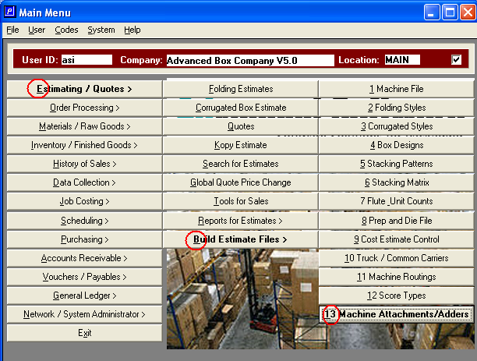

When establishing these adders the user should work with their production management or industrial engineer. The time values will either add set up hours per occurrence of the adder and / or reduce the run speed. Typical adders would be for hand holes, vent slots, saurer attachments, Q boards or corner cutting.

The adder codes are built by machine and can also be unique by style code within machine (in other words, the machine code is required, but the style restriction is optional). In the example below I have input a code for adding hand-holes for any style running on my flexo. The time is per hand-hole (occurrence = 1). Therefore, I can either use just one adder code (such as HH) and then change the quantity of hand holes on the routing screen, or I could put in two adder codes (such as HH1 and HH2) to represent specific times for one hand-hole versus two hand-holes. The only reason to do this would be if you believed that two hand-holes required less or more time than the one hand-hole adder hours times the routing screen adder quantity of 2.

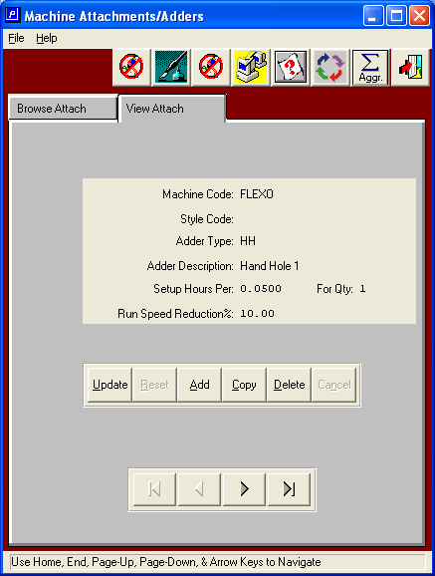

Once you have built the valid machine attachment / adder codes, you will be able to include them on the routing of the machine center. These adders will then alter the standard machine hours for the affected machine accordingly.

